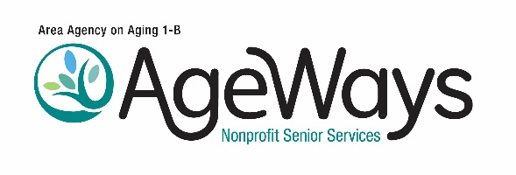
HOLIDAY MEALS ON WHEELS PLAN

Organization Name: Fiscal Year:
Contact Person: Contact Phone #:

- Indicate the three holidays you plan to serve, the projected number of meals, and the menu for each holiday:
 | Number Of Meals Requested | Menu To Be Served
Thanksgiving
(REQUIRED)

Christmas or Chanukah
(REQUIRED)

New Year’s Day
(OPTIONAL)

Easter or Passover
(OPTIONAL)

Other Holiday
(REQUIRES APPROVAL)

- Identify food preparation and donations as applicable:

Indicate Holiday:
Name and location of the kitchen that will be used to prepare the meals
Is the preparation kitchen the contractor’s main kitchen, a subcontractor’s kitchen, or a donated kitchen solely for the purpose of holiday meals only?

Does the prep kitchen have a valid food service license and has a copy been provided by AgeWays?
Is all or part of the meal’s food cost donated by another organization? If yes, indicate the same of the organization, which part of the meal is being donated, and the funding amount that is being donated, as applicable.

Will AgeWays funds be utilized to partially or fully reimburse the meal donor? If yes, indicate the amount as applicable.

List all sources of additional funding for holiday meals, and include the amount being donated as applicable.

- Indicate how potential recipients will be assessed to determine their need or desire to receive holiday meals.

- Identify volunteers to be used for holiday meal as applicable:
Indicate Holiday to serve:
How many volunteers will be utilized for the holiday

Will an outside organization be responsible for volunteer coordination on the day of service?

Identify the source of volunteers (i.e. community, corporation, university, etc.)

- Identify equipment used to maintain proper temperatures during delivery:

- Indicate how background checks will be completed prior to meal delivery:

AgeWays Use Only:
Approved Denied

Reimbursement Rate:
Thanksgiving:
Christmas/Chanukah:
New Year’s Day:
Easter:
Passover:
Other:

